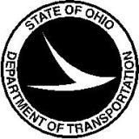
Notice from the Ohio Department of Transportation
DBE Utilization Plan
June 2, 2016
DBE Utilization Plan
ODOT implemented the DBE Utilization Plan for ODOT Let projects in June, 2015. In order to comply with FHWA requirements DBE Commitments will be gathered at bid time for all federally funded contracts. ODOT has been holding feedback sessions with local governments to communicate this change. As a result the Department is prepared to implement mandatory submission of DBE Utilization Plans at bid time on Local Let projects sold after July 1, 2016. The proposal note to support this process is being distributed and will be included when the project is advertised.
Training will be provided the week of June 20, 2016, and training documentation provided.
Should you have any further questions about these process changes, please contact Larry Brown or Tina Collins at certified.payroll@ohio.gov.

